EYARC Experience
BW Fishing Inc.

EYARC Experience Platform
EYARC Experience is an educational platform offering interactive activities and quizzes to help students understand and apply the concepts taught. Focusing more on application rather than evaluation through hands-on practice, EYARC Experience supports a love for learning, fostering deep comprehension and retention.

Logistics
Time to Complete (in minutes): 20 minutes
Assignment Difficulty: Beginner
Assignment Topic: Financial, data analytics, process mining, data visualization
Completion Measurement: Pages viewed
Grading Method: Quiz at the end of the assignment

Preview
Use process mining to analyze revenue transactions and identify issues contributing to the increase in uncollectible accounts receivable at BW Fishing Inc.

In this assignment, you will take on the role of the Vice President of Finance and Accounting at BW Fishing Inc. (BWF), a company that sells fishing supplies primarily to businesses. The focus will be on using process mining techniques to analyze and understand the company's increasing uncollectible accounts receivable. By examining dashboards that visualize revenue transaction flows, you will identify trends and issues within the revenue cycle, ultimately providing recommendations to improve the company's financial health.

Learning Objectives
- Understand how process mining can be used to visualize and analyze revenue transaction flows.
- Identify and address trends contributing to an increase in uncollectible accounts receivable.

Overview
You are Vice President of Finance and Accounting for BW Fishing Inc. (BWF). BWF sells fishing supplies mainly to businesses across the country. The company has grown steadily over the last 10 years. BWF found a strategic niche in fulfilling orders around the clock as soon as they are placed. As BWF’s customers order supplies at unusual hours, BWF’s “always open” mantra has received customer praise. This practice, along with competitive pricing, has allowed BWF to build a loyal network of customers.
Accounts Receivable, Allowance for Uncollectible Accounts and Bad Debt Expense
Most of BWF’s customers are businesses that make orders on account (i.e., BWF does not collect payment at the time of the order). BWF ships inventory to customers and bills customers at the time of shipment. As a result, BWF carries a large balance of accounts receivable on its balance sheet. At the end of each month, BWF estimates an allowance for uncollectible accounts and bad debt expense associated with the company’s accounts receivable.
To limit the number of uncollectible accounts receivable, BWF has a policy that all sales on account for more than $3,000 must be approved by the sales manager. The sales manager checks the customer’s credit and payment history to determine whether to approve or reject the customer’s order.
In your role as VP of Finance and Accounting, you regularly review the company’s financial statements to identify trends in the company’s financial performance. You recently noticed a concerning trend that the company’s allowance for uncollectible accounts as a percentage of accounts receivable has steadily increased over the past two years. As a result, the company’s allowance for uncollectible accounts and bad debt expense has increased.

Process Mining Dashboards for the Revenue Cycle
To better understand why uncollectible accounts receivable are increasing, you asked employees on your team to start using an innovative data analytics technique called process mining that will allow you to visualize and understand the flow of revenue transactions at BWF.
To give you preliminary insight into this issue, your team prepared several process mining dashboards for a set of BWF’s revenue transactions from the most recent month. In particular, the dashboards focus on a set of 499 revenue transactions from the most recent month.
The dashboards can be viewed using the following link: https://ey-academic-resource-center.eu-2.celonis.cloud/package-manager/ui/public/assets/fd0809d0-e51d-4c5d-b30f-f307aa8e3c4d.

The quiz will require you to answer questions from performing each of the steps demonstrated on the next several screens. Keep open the dashboard in a different tab so you can answer the questions on the quiz.

Discussion Questions
As you go through this assignment, consider the following questions:
- When considering accounting for simple transactions that follow the most common or “prescribed” route. How has using process mining changed your perspective about the actual flow of transactions within companies?
- Based on your analysis in this assignment, what changes should BWF consider implementing to address the increase in uncollectible accounts receivable?
- In this assignment, we used process mining to gain insight into a company’s uncollectible accounts receivable. What are some other ways you think companies could use this software?

Accessing the Variant Explorer Process Mining Dashboard
For this assignment, you will focus on the Variant Explorer process mining dashboard, which can be accessed by clicking on the Variant Explorer tab at the top of the screen (see the screenshot below).

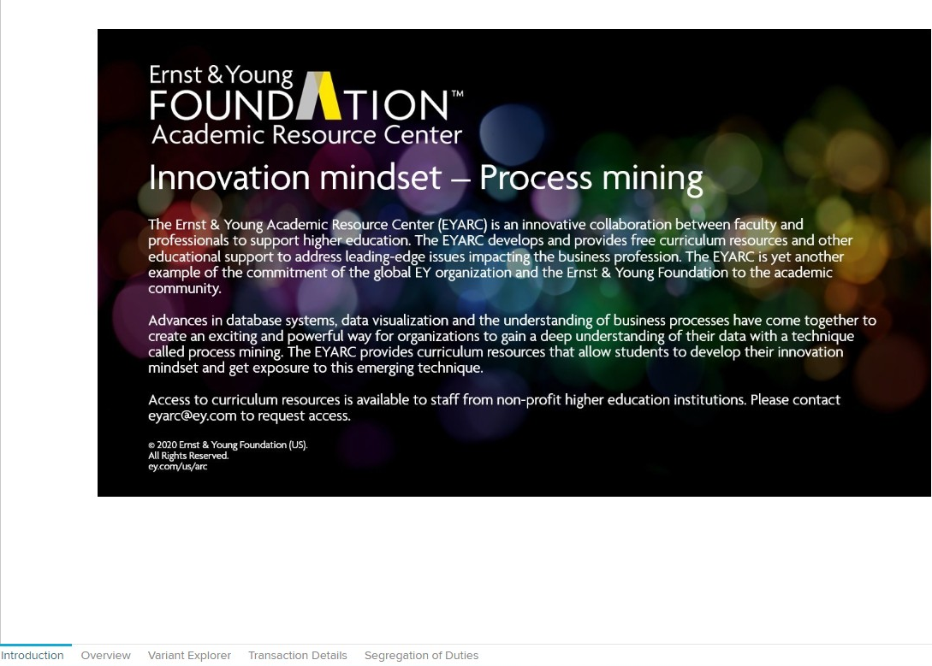
Click here to access the Variant Explorer process mining dashboard.

Exploring the Variant Explorer Process Mining Dashboard
The Variant Explorer illustrates the path revenue transactions traveled through BWF’s accounting and IT system. The initial screen shows the most common path that the 499 revenue transactions traveled. However, not all of the 499 revenue transactions traveled the same path. By clicking the + symbol by Variants in the lower left, you can see other paths that the 499 revenue transactions traveled through the company’s accounting and IT systems. Each time you click the + symbol, the dashboard shows more paths (or variants). See below for screenshots.
Step 1 (see Screenshot No. 1): When the Variant Explorer tab opens, the variant list already shows all the paths (variants) that the 499 revenue transactions traveled through BWF’s accounting and IT systems during the month, ranked from most common to least common. Confirm the checkbox at the top of the variant list is checked, which selects every variant.
- The area outlined in purple is the main part of the dashboard.
- The area outlined in green displays information about each of the paths (variants). You can hover over each path (variant) to see additional information, including how many transactions (cases) traveled that path.
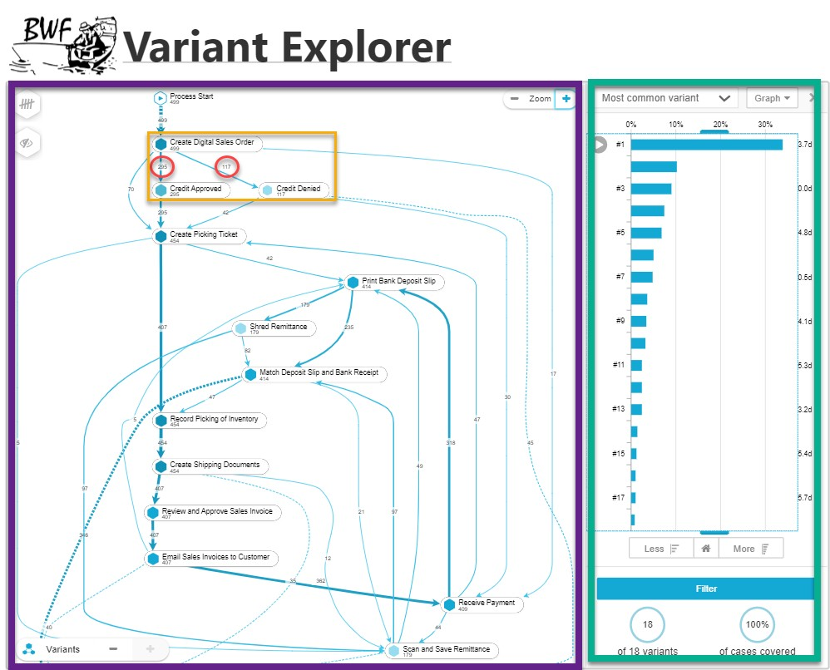
- The number in the middle of each line in the dashboard indicates how many transactions traveled that particular part of the path. For example, the area outlined in yellow shows that of the 499 digital sales orders created, the sales manager approved credit for 295 transactions and denied credit for 117 transactions.
Screenshot No. 1: Variant Explorer dashboard
Click the + symbol multiple times until the + symbol disappears. This reveals all the paths that the 499 different revenue transactions traveled during the month.

Were Orders Processed for Customers Who Were Denied Credit?
You want to use the Variant Explorer to better understand BWF’s increase in uncollectible accounts receivable. In particular, you are interested in knowing whether BWF is processing any orders on account for customers who were denied credit by the sales manager. Follow the steps below to investigate.
Step 2 (see Screenshot No. 2):
- Ensure you have completed Step 1 from the previous page.
- Click on the Credit Denied activity box in the main part of the dashboard. This immediately filters the dashboard to only the cases that include a Credit Denied event (a filter chip appears in the bar under the tabs).
- The main dashboard now displays the most common path taken by the 117 transactions for which credit was denied by the sales manager.
- Proceed to Step 3 on the next page.
Click on the “Credit Denied” event
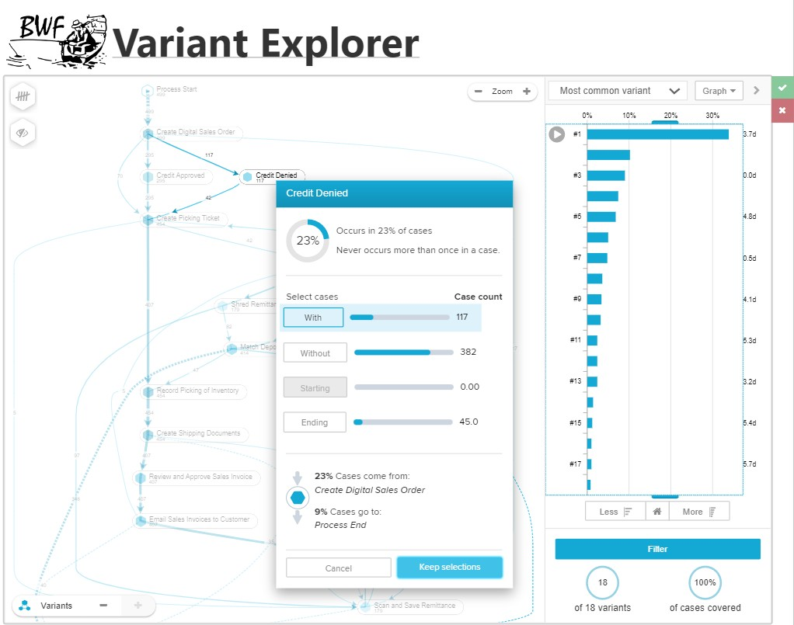
Screenshot No. 2: Drill down into Credit Denied in Variant Explorer dashboard

Click on Keep selections.
Click on With in the pop-up box that appears.
Step 3 (see Screenshot No. 3):
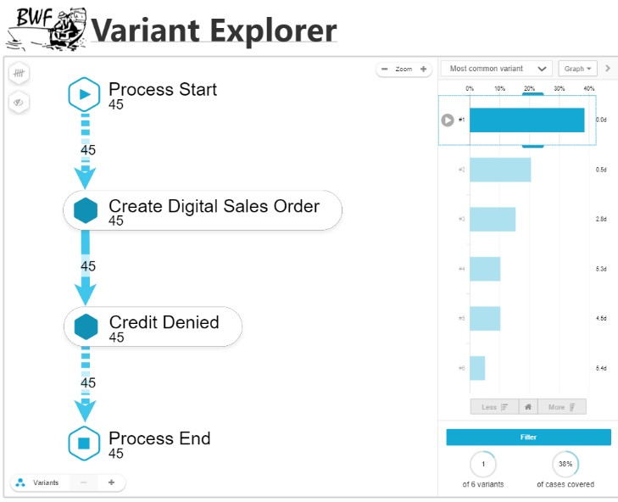

- Ensure you have completed Step 2 from the previous page.

- The variant list automatically updates to show all the paths (variants) associated with the 117 revenue transactions for which credit was denied by the sales manager — no further clicks are needed.
- The resulting dashboard should look similar to Screenshot No. 3.
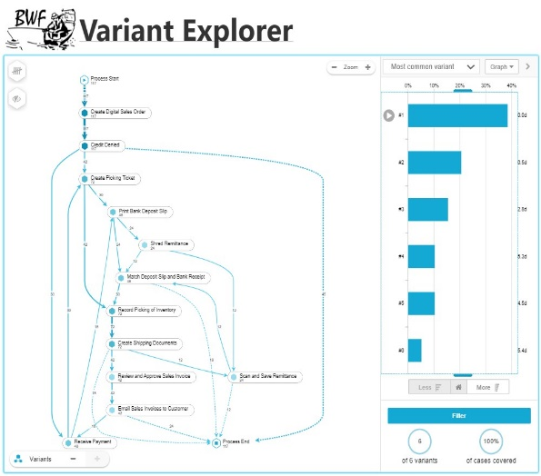
Click “+” by Variants to reveal more paths that revenue transactions traveled through BWF’s accounting and IT system.
Screenshot No. 3: Credit Denied
Quiz Questions
Answer each of following questions using the dashboard available at: https://ey-academic-resource-center.eu-2.celonis.cloud/package-manager/ui/public/assets/fd0809d0-e51d-4c5d-b30f-f307aa8e3c4d.

- Complete Step 1 to answer this question. How many transactions (cases) were part of the most common path – Variant #1?
  - 499 Incorrect. Too high! Look at the Cases column for the Variant #1 row in the variant list in the Variant Explorer tab (or hover over the row) to see how many cases occurred.
  - 169 Correct! The path with the most cases is shown clearly in the graph with Variant #1 having 169 cases.
  - 51 Incorrect. Too low! Look at the Cases column for the Variant #1 row in the variant list in the Variant Explorer tab (or hover over the row) to see how many cases occurred.
  - None of the above. Incorrect. Try again! Look at the Cases column for the Variant #1 row in the variant list in the Variant Explorer tab (or hover over the row) to see how many cases occurred.

- Complete Step 1 to answer this question. How many transactions (cases) were part of the fifth most common path – Variant #5?
  - 499 Incorrect. Too high! Once you open the dashboard, click the Variant Explorer tab to see the variant list, ranked by number of cases. Look at the Cases column for the Variant #5 row (or hover over it) to see how many cases occurred.
  - 169 Incorrect. Too high! Once you open the dashboard, click the Variant Explorer tab to see the variant list, ranked by number of cases. Look at the Cases column for the Variant #5 row (or hover over it) to see how many cases occurred.
  - 34 Correct! The path with the fifth most common path is shown clearly in the graph with Variant #5 having 34 cases.
  - None of the above Incorrect. Try again! Once you open the dashboard, click the Variant Explorer tab to see the variant list, ranked by number of cases. Look at the Cases column for the Variant #5 row (or hover over it) to see how many cases occurred.

- Complete Steps 1 through 3 to answer this question. Focus on the Credit Denied and the Process End events in the dashboard. The Credit Denied event means that the sales manager rejected the customer’s order for bad credit reasons. The Process End event means BWF ended the order and took no further action. How many transactions occurred where the customer was denied credit and the company therefore ended the order process?
  - 117 Incorrect. Too high! After completing steps 1-3, look at the Cases column for the Variant #1 row in the variant list (or hover over it) to see how many cases occurred where the order was ended after the credit was denied.
  - 45 Correct! After completing steps 1-3 and referencing the graph on the right, Variant #1 has 45 cases where the order was ended after the credit was denied.
  - 42 Incorrect. Too low! After completing steps 1-3, look at the Cases column for the Variant #1 row in the variant list (or hover over it) to see how many cases occurred where the order was ended after the credit was denied.
  - 30 Incorrect. Too low! After completing steps 1-3, look at the Cases column for the Variant #1 row in the variant list (or hover over it) to see how many cases occurred where the order was ended after the credit was denied.

- Complete Steps 1 through 3 to answer this question. Focus on the Credit Denied and the Create Picking Ticket events in the dashboard. The Credit Denied event means that the sales manager rejected the customer’s order for bad credit reasons. The Create Picking Ticket event means BWF processed the order by asking the inventory warehouse to “pick” and send inventory to the customer. How many transactions occurred where the customer was denied credit, but the company still created a picking ticket and processed the order?
  - 117 Incorrect. Too high! After completing steps 1-3, hover over (or click) the connection between Credit Denied and Create Picking Ticket on the process map to see the case count in the tooltip.
  - 45 Incorrect. Too high! After completing steps 1-3, look at the Cases column for the Variant #1 row in the variant list (or hover over it) to see how many cases occurred where the order was ended after the credit was denied.
  - 42 Correct! After completing steps 1-3 and hovering over (or clicking) the connection between Credit Denied and Create Picking Ticket on the process map, you will see the tooltip stating 42 cases of this connection.
  - 30 Incorrect. Too low! After completing steps 1-3, look at the Cases column for the Variant #1 row in the variant list (or hover over it) to see how many cases occurred where the order was ended after the credit was denied.

- As noted in the assignment, you are concerned about an increase in BWF’s uncollectible accounts receivable (and corresponding uncollectible account expense). Which transaction path discussed in questions 3 and 4 above could best explain this increase?
  - Transactions where credit was denied (Credit Denied event), but the company still created a picking ticket and processed the order (Create Picking Ticket event). Correct! Managers deny credit for customers whose credit history reflects an inability to pay for previous credit purchases. Allowing these customers to still receive their order after their credit was denied presents a high risk for being unable to collect payments, which would explain the increase in BWF’s uncollectible accounts.
  - Transactions where credit was denied (Credit Denied event), so the company therefore ended the order process (Process End event). Incorrect. Ending the order process for customers whose credit was denied ensures BWF only conducts business with customers who have a history of paying for purchases made on credit. This would increase the likelihood BFW can collect payments from these customers.

